HOW TO CREATE A USER IN CLM?

1. Login to Jazz Team Server admin panel ([*https://inbasdpc06348.techmahindra.com:9443/jts/admin*](https://inbasdpc06348.techmahindra.com:9443/jts/admin)) as administrator.
2. Navigate to the administration button, click on it and select **Manage Users** from the drop down.

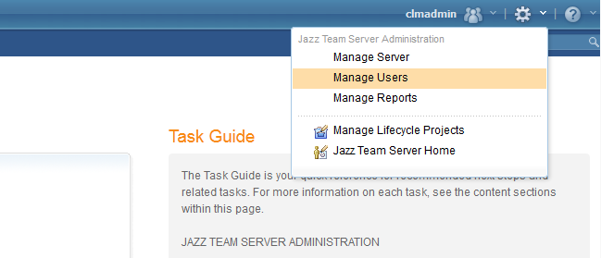

1. Now you are on the **Active Users** page. To create a new user click on Create User button  on the top-right corner of the page. It will take you to the **Edit User** page, there enter a Username, User ID, e-mail and Photo (optional). Then, provide appropriate **Client Access License** and **Repository Permissions** to the user. Here, I am creating a simple user so I am giving the user the **Rational Team Concert – Developer** license and **JazzUser** repository permission. Then click **Save** to complete the user creation.

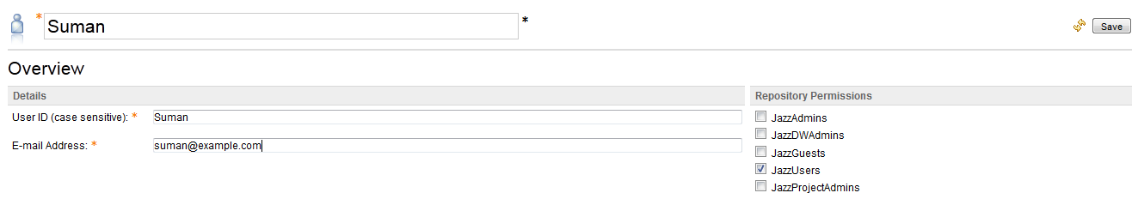  
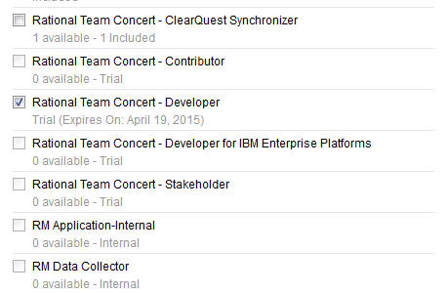

A complete reference to Client Access License: [*https://www-01.ibm.com/support/knowledgecenter/SSYMRC_6.0.0/com.ibm.jazz.repository.web.admin.doc/topics/c_license_mgmt_over.html*](https://www-01.ibm.com/support/knowledgecenter/SSYMRC_6.0.0/com.ibm.jazz.repository.web.admin.doc/topics/c_license_mgmt_over.html)

A complete reference to Repository Permissions*:* [*https://www-01.ibm.com/support/knowledgecenter/SSYMRC_6.0.0/com.ibm.jazz.platform.doc/topics/c_permissions.html*](https://www-01.ibm.com/support/knowledgecenter/SSYMRC_6.0.0/com.ibm.jazz.platform.doc/topics/c_permissions.html)